# Nutrients In Food

This is just a written notes of what I have learn about nutrients in food. I will keep adding some notes of what I have learn. I am not expert in nutrients but try to express the knowledge I learn into words.

## Calculating Nutrients In Food

New methods and technologies emerges in calculating nutrients in food plus the force of government policy. Now to the know the composition of nutrients in food is not a mystery. Also new technologies arise to more accurately calculating only the portion needed, for instance when water percentage of the food are available, estimates of nutrients amounts are adjusted for the water content only. Food are calculated only for the edible portion only, for instance a chicken leg is for the meat only not the bone.

Many factors affect the nutrient values of the food. Such factors includes mineral content of the soil, fertilizer used, genetics of the plant or animal, diet of the animal, method of processing, season of the year, storage method and cooking method. Talking about method of processing, the thing I learned is frozen food will show a larger amount of nutrient compared to the same portion of the fresh or cooked fresh item. This is because freezing breaks down the cell wall of the food, resulting more denser food when cooked or severed. Cooking method also is an issue, sometimes cooking cause moisture loss, which also costs more dryer, which has higher nutrient density.

## Nutrients From Food Or Supplements

Nutrients can be absorb from food or by taken supplements. We sometimes needs to take supplements because it is not readily available in the food or not adequate, such as folate which are more bio available in supplement than food. Absorption is also an issue, retionol are almost fully absorbed without food. Also research shows that there are good benefit of concentrated dosage for some forms of supplements , however, there are adverse effect for prolonged concentrated intake.

## Consideration when taken supplements

Nutrient seldom work in isolating from others. Most nutrient requires other nutrient to be present to do their job well. For instance vitamin A, D, E, K and carotenoids required fats to be absorbed. Some supplements contains in dried form of fruits/vegetables in the essence of air which becomes oxidized and ineffective, for instance carotenoids, which is more stable in foods. If the process was done in an closed-air condition, only partial affected. Another thing to concern is overdoes intake, studies show that overdose intake supplement would overwhelm the body’s mechanism for absorbing other nutrients, that causes blocking the absorption of the others, resulting deficiencies in other nutrients even when dietary intake adequate.

## Food Labels For the U.S. (Not For Other Countries)

For food labels, In 1997 and 1998, the Dietary Reference Intake (DRIs) will be replace by the old standard Recommended Dietary Allowances (RDAs) which is used since the year 1989. New recommendations were published for 14 nutrients. The 14 nutrients are:

### New DRI Standard Published In 1997 - 1998

**From the Year 1997**

* Calcium
* Phosphorus
* Magnesium
* Vitamin D
* Fluoride

**From the Year 1998**

* Thiamin
* Riboflavin
* Niacin
* Vitamin B6
* Folate
* Vitamin B12
* Pantothenic Acid
* Biotin
* Choline

### RDA Standard Published In 1989

* Protein
* Vitamin A
* Vitamin E
* Vitamin K
* Vitamin C
* Iodine
* Iron
* Selenium
* Zinc

Please take **note** we are talking about **nutrients** not **minerals**. The new DRI standard is the average intake of essentials nutrients that is sufficient to meet nearly all (97 -98%) of healthy persons in a particular life stage. DRI is only used as a goal for individuals. If a nutrient cannot be determined from the DRI framework then the term **Adequate Intake (AI)** will be used. Adequate Intake is based on observed or experimentally which is determined approximately of nutrient intake by a group of healthy people. All infants including breast-fed infants are considered to use the adequate intake by using calculating the mean or average intake of the nutrients.

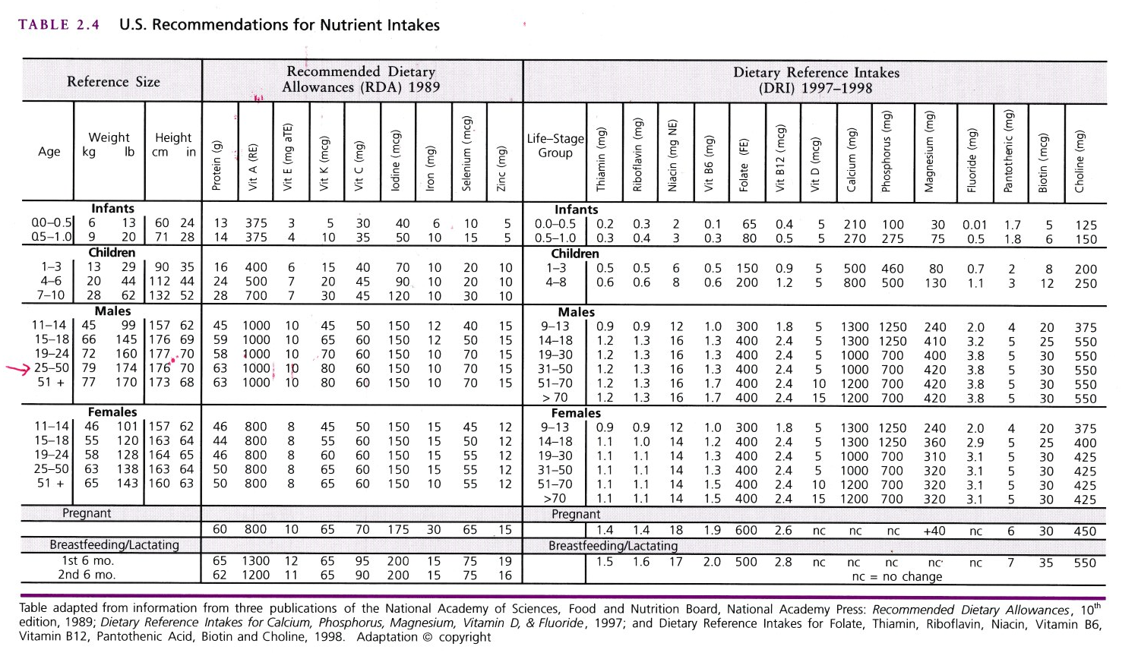

The chart above shows the recommendations Nutrient Intakes, Both the RDA and DRI recommended nutrients are displayed base on the age group.

## U.S. Estimate Safe and Adequate Daily Intakes

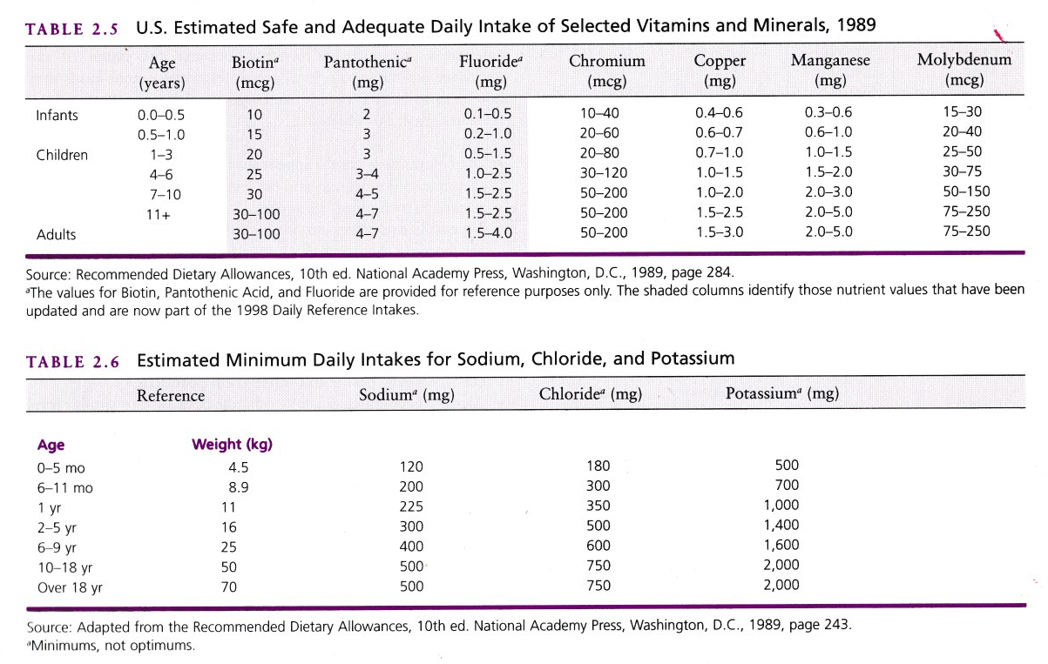

The 1989 Estimate Safe and Adequate Intakes the chart above are presented as a range of values because there is less scientific information on which to base a single recommended amount. It is recommended that the upper values for these trace elements should not exceeded habitually because toxic levels may only be several times the usual intakes.

## Diabetic Food Exchanges

Food Exchange, also referred to as Diabetic Exchanges, are a popular method for understanding and gaining control over calorie intake from fat and carbohydrates. Although food exchanges do not consider vitamin and mineral intake and are not precise, they provide a excellent tool for many individuals.

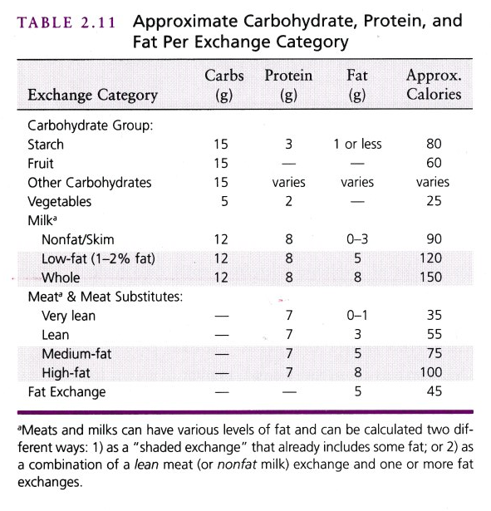

The exchange system is base on **eight** groupings of food. Within each group, foods have similar calorie, protein, carbohydrate, and fat values per serving. A food from one group can be exchanged for another food in that group.

### 8 groups of food for exchange

* Bread/Starch
* Other Carbohydrates
* Very Lean Meat
* Lean Meat
* Fruit
* Vegetables
* Milk (non fat)
* Fat

## Sources Of Energy/Calories

Protein, carbohydrates, fat and alcohol are the components of foods that contribute calories to our diets. Therefore to calculate total calories in foods, the general 4-4-9 formula can be used. One would multiply the known weight of carbohydrate and protein by 4 and the known weight of fat by 9, then add the numbers together for the total calories in the food.

Below the chart is the 4-4-9 formula for calculating total calories

